
Banco Santander
Machine Learning and innovation

ENSEMBLING MODELS

INDICE
1. Steps of Data Exploration and Preparation 2
Univariate Analysis 2
Bi-variate Analysis 2
Categorical & Categorical 3
Categorical & Continuous 4
2. Missing Value Treatment 4
Why my data has missing values? 4
Which are the methods to treat missing values ? 4
Deletion 4
Mean/ Mode/ Median Imputation 5
Prediction Model 5
KNN Imputation 5
3. Techniques of Outlier Detection and Treatment 6
What is an Outlier? 6
What are the types of Outliers? 6
What causes Outliers? 6
What is the impact of Outliers on a dataset? 7
How to detect Outliers? 7
How to remove Outliers? 8
Deleting observations 8
Transforming and binning values 8
Imputing 8
Treat separately 8
4. The Art of Feature Engineering 9
What is Feature Engineering? 9
What is the process of Feature Engineering ? 9
What is Variable Transformation? 9
When should we use Variable Transformation? 9
What are the common methods of Variable Transformation? 10
What is Feature / Variable Creation & its Benefits? 10

What is ensembling?
In general, ensembling is a technique of combining two or more algorithms of similar or dissimilar types called base learners. This is done to make a more robust system which incorporates the predictions from all the base learners. It can be understood as conference room meeting between multiple traders to make a decision on whether the price of a stock will go up or not.
Since all of them have a different understanding of the stock market and thus a different mapping function from the problem statement to the desired outcome. Therefore, they are supposed to make varied predictions on the stock price based on their own understandings of the market.
Now we can take all of these predictions into account while making the final decision. This will make our final decision more robust, accurate and less likely to be biased. The final decision would have been opposite if one of these traders would have made this decision alone.

Types of ensembling
Some of the basic concepts which you should be aware of before we go into further detail are:
- Averaging: It’s defined as taking the average of predictions from models in case of regression problem or while predicting probabilities for the classification problem.
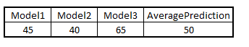
- Majority vote: It’s defined as taking the prediction with maximum vote / recommendation from multiple models predictions while predicting the outcomes of a classification problem.
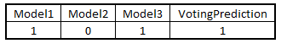
- Weighted average: In this, different weights are applied to predictions from multiple models then taking the average which means giving high or low importance to specific model output.
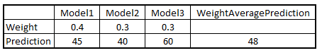
Practically speaking, there can be a countless number of ways in which you can ensemble different models. But these are some techniques that are mostly used:

- Bagging: Bagging is also referred to as bootstrap aggregation. To understand bagging, we first need to understand bootstrapping. Bootstrapping is a sampling technique in which we choose ‘n’ observations or rows out of the original dataset of ‘n’ rows as well. But the key is that each row is selected with replacement from the original dataset so that each row is equally likely to be selected in each iteration. Let’s say we have 3 rows numbered 1, 2 and 3.
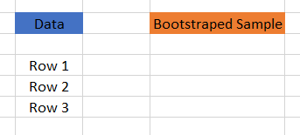
For bootstrapped sample, we choose one out of these three randomly. Say we chose Row 2.
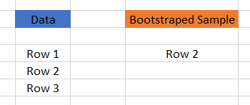
You see that even though Row 2 is chosen from the data to the bootstrap sample, it’s still present in the data. Now, each of the three:
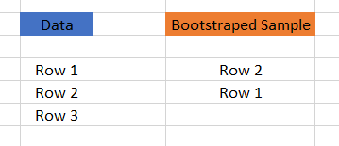
Rows have the same probability of being selected again. Let’s say we choose Row 1 this time.
Again, each row in the data has the same probability to be chosen for Bootstrapped sample. Let’s say we randomly choose Row 1 again.
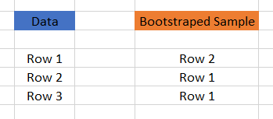
Thus, we can have multiple bootstrapped samples from the same data. Once we have these multiple bootstrapped samples, we can grow trees for each of these bootstrapped samples and use the majority vote or averaging concepts to get the final prediction. This is how bagging works.
One important thing to note here is that it’s done mainly to reduce the variance. Now, random forest actually uses this concept but it goes a step ahead to further reduce the variance by randomly choosing a subset of features as well for each bootstrapped sample to make the splits while training.
- Boosting: Boosting is a sequential technique in which, the first algorithm is trained on the entire dataset and the subsequent algorithms are built by fitting the residuals of the first algorithm, thus giving higher weight to those observations that were poorly predicted by the previous model.
It relies on creating a series of weak learners each of which might not be good for the entire dataset but is good for some part of the dataset. Thus, each model actually boosts the performance of the ensemble.
It’s really important to note that boosting is focused on reducing the bias. This makes the boosting algorithms prone to overfitting. Thus, parameter tuning becomes a crucial part of boosting algorithms to make them avoid overfitting.

- Stacking: In stacking multiple layers of machine learning models are placed one over another where each of the models passes their predictions to the model in the layer above it and the top layer model takes decisions based on the outputs of the models in layers below it.
Let’s understand it with an example:
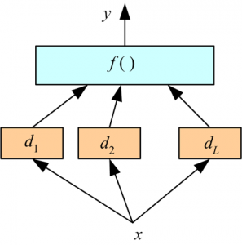
Here, we have two layers of machine learning models:
- Bottom layer models (d₁, d₂, d₃ ) which receive the original input features(x) from the dataset.
- Top layer model, f() which takes the output of the bottom layer models (d₁, d₂, d₃ ) as its input and predicts the final output.
- One key thing to note here is that out of fold predictions are used while predicting for the training data.
Here, we have used only two layers but it can be any number of layers and any number of models in each layer. Two of the key principles for selecting the models:
- The individual models fulfill particular accuracy criteria.
- The model predictions of various individual models are not highly correlated with the predictions of other models.
One thing that you might have realized is that we have used the top layer model which takes as input the predictions of the bottom layer models. This top layer model can also be replaced by many other simpler formulas like:
- Averaging
- Majority vote
- Weighted average

Advantages and Disadvantages of ensembling
Advantages
- Ensembling is a proven method for improving the accuracy of the model and works in most of the cases.
- It is the key ingredient for winning almost all of the machine learning hackathons.
- Ensembling makes the model more robust and stable thus ensuring decent performance on the test cases in most scenarios.
- You can use ensembling to capture linear and simple as well non-linear complex relationships in the data. This can be done by using two different models and forming an ensemble of two.

Disadvantages
- Ensembling reduces the model interpretability and makes it very difficult to draw any crucial business insights at the end.
- It is time-consuming and thus might not be the best idea for real-time applications.
- The selection of models for creating an ensemble is an art which is really hard to master.

